Isabel Rivera, Carlos Gil, Dustin Nguyen

IE 492-451

Prof. Karnik

Team 4 Project Proposal

1. **Project ideas:**

Option 1(Carlos):

Update business network infrastructure, in every department. Set up a system by which each department will be ranked based on need for update. Update includes, ethernet wires, hardware, and cable drop spaces.

Option 2(Isabel):

Create a small business layout, establish hardware and software standards for the business model. Set up POS systems at key locations, and desktop/laptop connections where needed.

Option 3(Dustin):

Create and implement an ERP system or module to increase the efficiency of business processes for a large or medium sized company. A full system may be a bit ambitious, if so a smaller module that would focus on improving a specific department or business function could be manageable.

2. **Decisioning process:**

For step 2, we came to the decision to do option one because it's based more on our majors, and heavier on hardware for technology

**Criteria:**

* Relevance to degreework
* Scope, limit the scope to a project plannable by three people

We decided to select the project idea based upon what is more relevant to the majors of our group as we are not engineering majors like other groups. We also decided to limit the scope of our project to something that is manageable by three people so that sufficient detail can be provided.

3. **Selected Idea:**

We decided to go forward with Carlos’s idea because it is more relevant to the IT majors of the group and it helps limit the scope by working with an existing infrastructure instead of trying to build something from scratch. Isabel and Carlos also have experience dealing with Cisco and Cisco standards, which includes updating existing hardware and software configurations. Dustin is not an IT major, but is currently taking a class about system analysis and design, so figuring out functional requirements for an updated system could be a complementary skill.

4. **Project objective:**

Create and implement an easily followable project plan for updating the existing networks of a four story high school, with a schedule prioritized to provide the most beneficial updates first. This should be accomplished within a school year (9 months) with a budget of $100,000.

5. **Statement of Work:**

**Task 1: Assess current infrastructure**

Assess existing department infrastructure, to determine how severely it needs updating. Departments will be examined and put into a list of prioritization to inform the schedule of the project. Outline where each room is and determine if any expansion is required to accommodate new infrastructure. This should be accomplished within 3 weeks.

**Task 2: Create a plan to prioritize update of most vital functions of the infrastructure**

After determining the most vital functions of the infrastructure, a plan to update the most important departments and functions first will be created under the assumption that there is a hard time requirement for the project. This should be accomplished within 4 weeks after the completion of the assessment.

**Task 3: Implement the plan**

After finalizing the prioritization of department updates, the infrastructure should be fully updated and functional before the start of the next school year, September 2022. This implementation includes the acquisition of the required resources and technologies and the installation of the equipment.

6. **Assumptions**:

1. Total time to update the network will be substantial.
2. Occasional network slowdown when replacing equipment.
3. Network is usable throughout the entire update process.
4. Save as much of the existing infrastructure as possible without sacrificing standards.
5. Try to future proof and keep cables as neat as possible in case there are problems with the network not working.

7. **Type of contract:**

This type of contract would be cost-reimbursement. This type of project has the possibility of incurring unexpected cost, but also going under budget by the end of the project. The reason for that would be because most of the equipment and wiring should be re-usable, but there is also the possibility that an animal has gotten into the wiring and destroyed it, or to meet the need to update the wires and racks to meet new standards. There is also a possibility of going over time due to the network needing to be workable while the project is being undertaken. There is also the possibility that the wiring is completely unorganized, causing the need for us to undo everything on the rack and start from scratch.

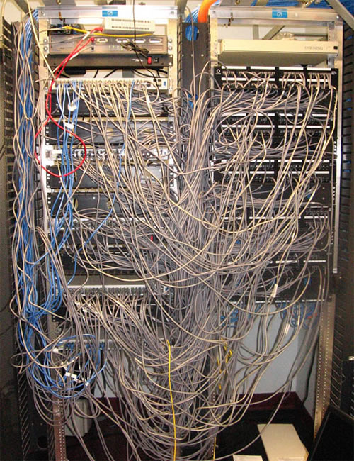

This is the type of racks we may encounter, which would increase the time we take to complete the objective.

8. **Deliverables:**

1. **A complete survey of the existing infrastructure of the business.** 
   1. This survey is required to understand what infrastructure exists, what updates are required, and which of those updates are most vital.
   2. This assessment will be performed and approved by us as the contractor, unless the school requests an outside expert opinion.
   3. This survey should take no more than 3 weeks to complete.
2. **A prioritized list of critical updates needed by the system.**
   1. This allows the company to have their pain points alleviated, in the most time efficient way.
   2. Lists will include notes of any building renovations and specific materials needed for the upgrade of an area.
   3. List should take about 2 weeks to complete.
3. **An in-depth plan to update the infrastructure**
   1. This plan will include the resources required and time needed to complete updates in the order that would provide the most benefit to the business first. This is the final deliverable that will be passed off to a separate contractor with the resources to implement.
   2. This should take no longer than two weeks to complete.
4. **Implementation of a fully updated and functional infrastructure**
   1. This involves executing all the tasks necessary to update the infrastructure. This includes the procurement of the necessary hardware, the correct uninstallation of unnecessary resources, and the installation of new or reused hardware.
   2. As the final deliverable, this should be accomplished by the beginning of the next school year, September 2022.

9. **Approval Section:**

This section should include each team member’s name and initials.

The goal for this section is to demonstrate each team member’s agreement to the contents of the deliverable.

**Dustin Nguyen DN**

**Carlos Gil CG**

**Isabel Rivera IR**